**ASSIGNMENT 01**

**NAME: M Umer Sheraz**

**SAP ID: 71033894**

**COURSE: Backend**

**SUBMITTED TO: Sir Amish Hassan**

* **QUESTION NO 01**

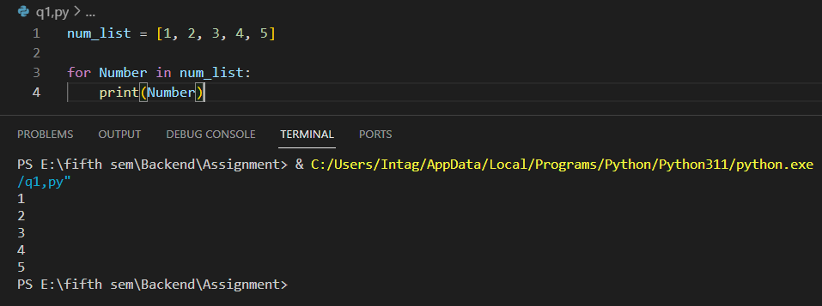

* **QUESTION NO 02**

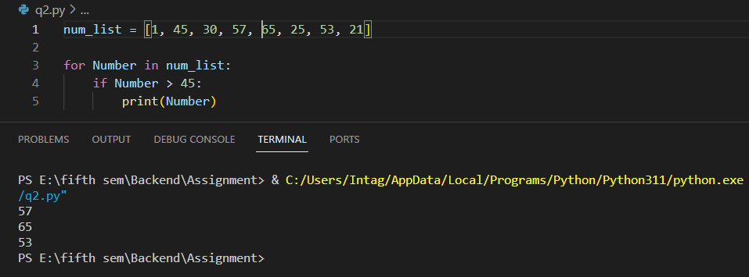

* **QUESTION NO 03**

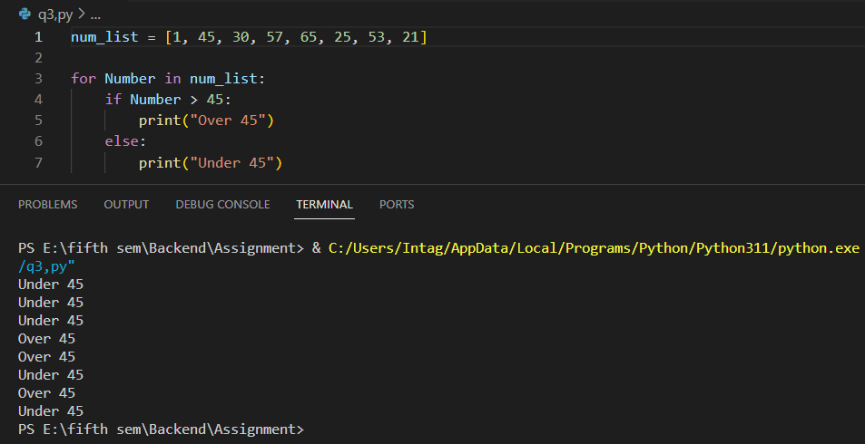

* **QUESTION NO 04**

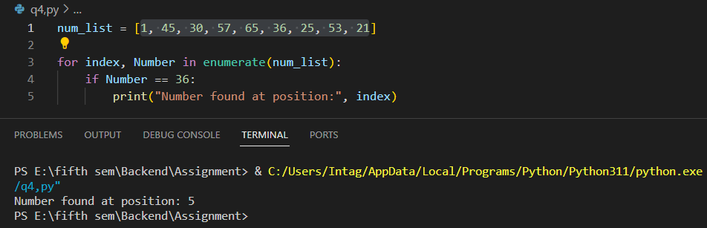

* **QUESTION NO 05**

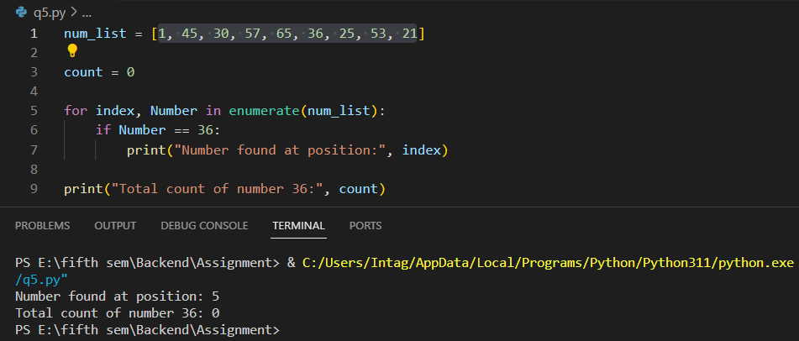

* **QUESTION NO 06**

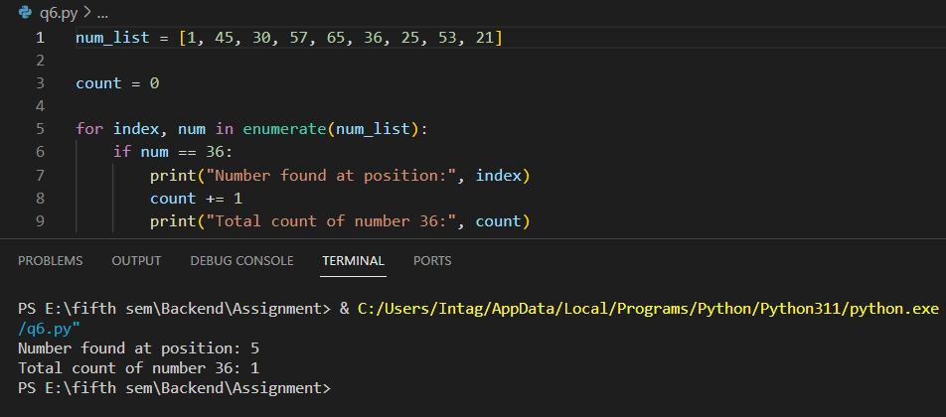

* **QUESTION NO 07**

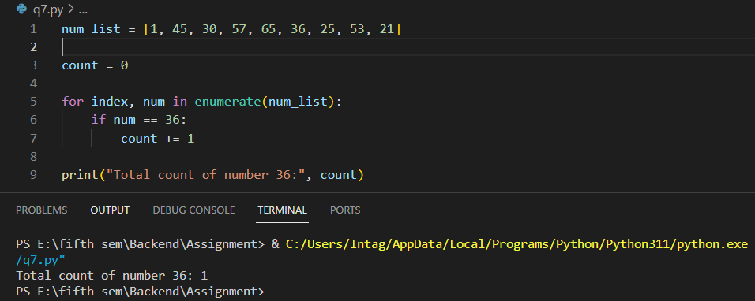

* **QUESTION NO 08**

